*Neural Networks Task 2*

# 

# Table of Contents

**Table of Contents 1**

**Team Information 2**

**Model Analysis 3**

Sigmoid Test: 3

Given Parameters 3

Metrics 3

Confusion Matrix 3

Hyperbolic-Tangent Test: 4

Given Parameters 4

Metrics 4

Confusion Matrix 4

**Conclusion 5**

# 

# Team Information

**Team ID: 5**

| **Member name** | **Department** | **IDs** |
| --- | --- | --- |
| عمر احمد فاروق احمد الجبالي | CS | 20201701162 |
| عماد محمود عمر الفاروق محمود | CS | 20201700517 |
| عمر احمد محمد عبدالمعطي | CS | 20201700524 |
| عمر عبدالفتاح عبدالسميع ابراهيم | CS | 20201700538 |
| محمد ابراهيم سعيد امام | CS | 20201700650 |
| محمد اسامه كمال يوسف | CS | 20201700665 |

# **Model Analysis**

## **Sigmoid Test:**

### Given Parameters

| ***Hyper-Parameters*** | ***Values*** |
| --- | --- |
| Epochs | 1000 |
| Learning Rate (ETA) | 0.01 |
| Number of Hidden Layers | 2 |
| Number Of Hidden Parameters | [3, 4] |

### Metrics

| ***Measures*** | ***Values*** |
| --- | --- |
| Mean Squared Error (MSE) | 0.3460667 |
| Train-Accuracy | 100% |
| Test-Accuracy | 100% |

### Confusion Matrix

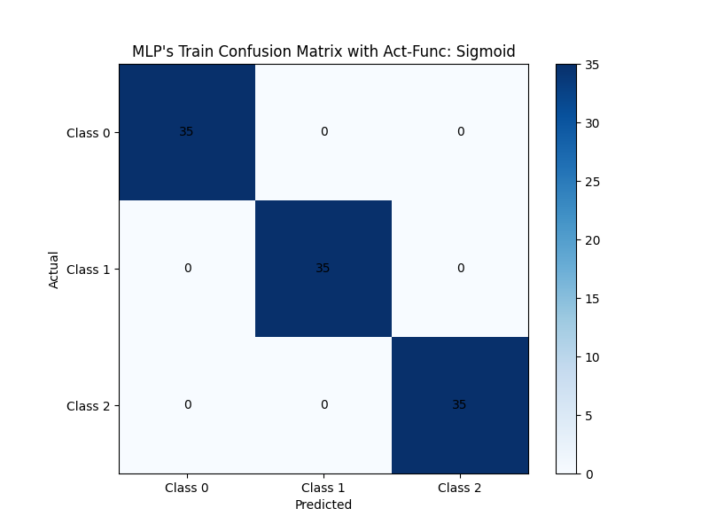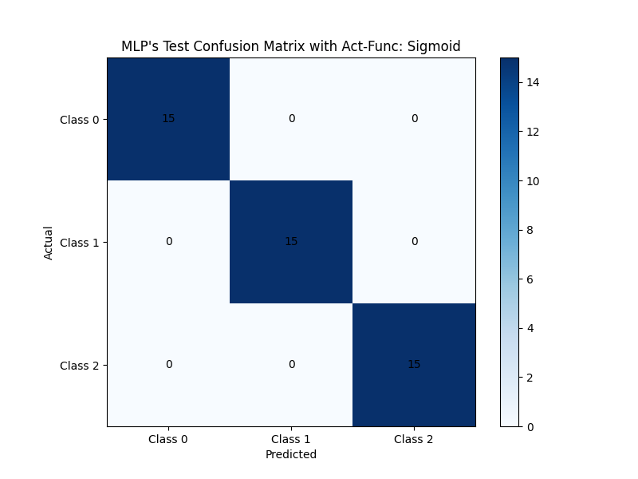

## 

## **Hyperbolic-Tangent Test:**

### Given Parameters

| ***Hyper-Parameters*** | ***Values*** |
| --- | --- |
| Epochs | 5000 |
| Learning Rate (ETA) | 0.001 |
| Number of Hidden Layers | 1 |
| Number Of Hidden Parameters | [5] |

### Metrics

| ***Measures*** | ***Values*** |
| --- | --- |
| Mean Squared Error (MSE) | 0.002397 |
| Train-Accuracy | 100% |
| Test-Accuracy | 100% |

### Confusion Matrix

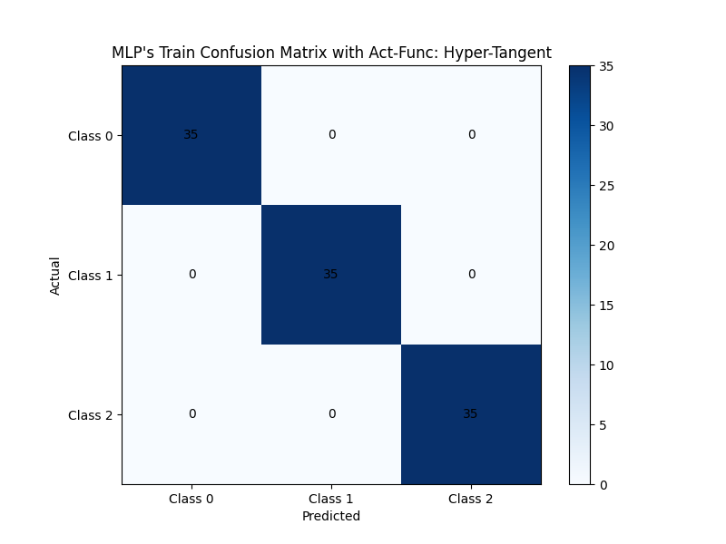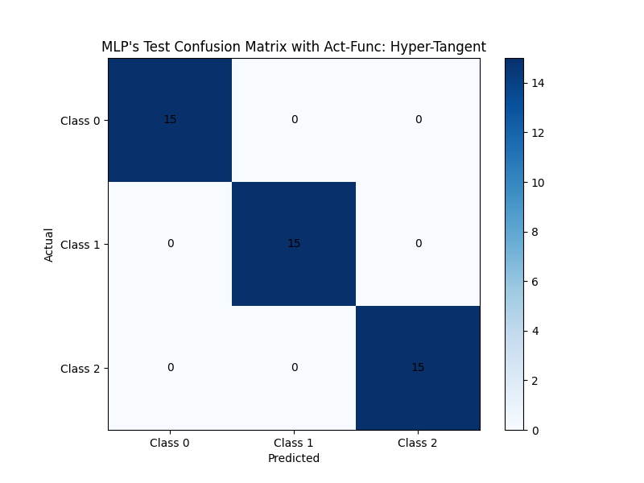

# 

# **Conclusion**

In conclusion, There are multiple factors that affects accuracy of Multi-Layer Perceptron with both activation functions Sigmoid and Hyperbolic-Tangent.

1. Initial Weights: As they are randomly generated in each fit, different accuracies (also different MSE) appears with low variations ~0.9 to ~1.
2. Increasing the epochs or decreasing the learning rate, makes a highly positive change in the performance of each activation function and vice versa.
3. Increasing the number of neurons in a layer mostly resulting better in accuracy.
4. Increasing the number of layers too much causes an overfitting.

Number of layers mostly fitted well is 1 with number of neurons higher than 4 and 2 with number of neurons higher than 3 in each layer.

To have the most likely weights in a current hyper-parameters, using the method of fitting the model multiple times and save/use the weights with the highest accuracy and lowest MSE.